**Electronics Refurbishment**

**Portfolio**

**Evan Frackelton**

**Mechatronics Engineer**

**Table Of Contents**

1. **Gameboy Advance SP (Zelda Edition) 3**

**Gameboy Advance SP (Zelda Edition)**

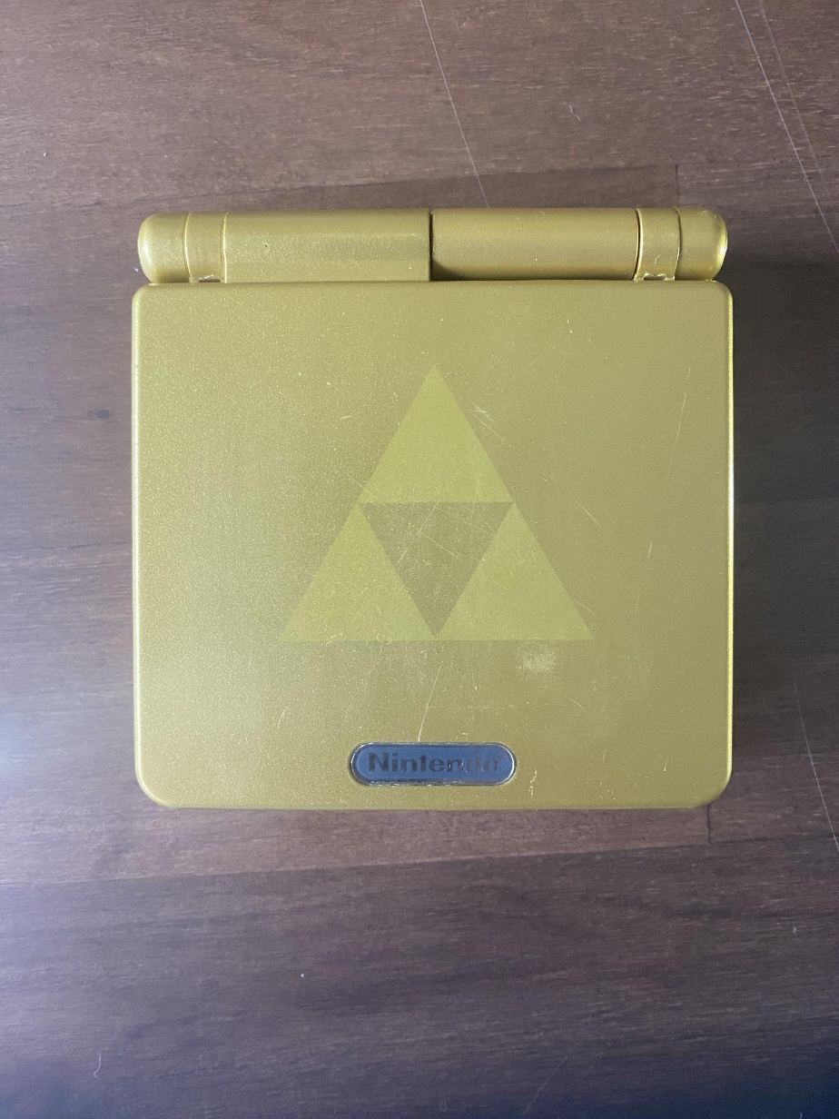

*Figure 1: Outside Case*

**Problems:**

* Console turns on but shuts off randomly
* Expanded Lithium Ion Battery
* Dirty motherboard board and components
* Corroded Ports

**Repairs:**

The motherboard was dusty so IPA was used to clean it as well as the ports and components. The power switch was dirty which was causing the console to randomly shut off. Taking out the switch, cleaning it, and resoldering it fixed that issue. The battery was also replaced because the original was slightly bloated. The ports are corroded but it does not seem to be affecting the continuity. The case was also fully cleaned with IPA as well as the inside of the case below the motherboard, including the buttons and speaker.

**Gameboy Color (Clear Purple)**